Making money with the Cloud

Instructions

|  |  |
| --- | --- |
| Versie: | 1.1 |
| Datum: | April 2017 |
| Auteur: | Leen Blom |
| Afdeling: | Enterprise Innovation |
|  |  |
|  |  |
|  |  |
|  |  |
|  |  |
|  |  |

Content

1 Instruction 4

1.1 Agenda 4

1.2 Advisory Board and Jury 4

2 Context and instruction 5

2.1 Direct Trading disrupts commercial world 5

2.2 Start a virtual company 5

3 Expected result 7

3.1 Assessment criteria 8

4 How to use the financial sheet 9

Copyright 2017, Centric Netherlands B.V.

# Instruction

Goal of this assignment to identify and develop Cloud services that can help startups. Not just by looking at their pros and cons, but also by taking into account the financial consequences. In short: define a new business based on Cloud services and prove that your startup will be profitable in a reasonable time frame.

## Agenda

|  |  |  |  |
| --- | --- | --- | --- |
| Date | Duration | Topic | Description |
| April 4-22 |  | Homework | Assignment and preparation for assessment |
| May 8th |  | First groups present |  |
| May 9th |  | Last groups present |  |

## Advisory Board and Jury

1. Professor L. Alboaie, Alexandru Ioan Cuza University
2. L. Blom, Centric Netherlands BV

# Context and instruction

## Direct Trading disrupts commercial world

Uber disrupts the world of taxi companies and AirBnB is superseding hotels in the world. It is the dream of any entrepreneur to start something that has the same impact as Facebook or Google. However, that is not the focus of this assignment! For you we selected a domain that needs to be shaken by you. It is the world of commerce. Of course, e-commerce is already disrupting the traditional retail market. But we think there is an area where you could stir the old and settled world of wholesale with its purchasing organisations, distribution centres and other cost-increasing activities. Imagine a world where SME’s and individuals can trade without men-in-the-middle. Where apple growers sell directly to you and me and where manufacturers sell their goods directly to individuals. That would cut out a whole chain of service providers, making products either cheaper, more lucrative or more custom made. We call that Direct Trading.

## Start a virtual company

This is a chance you are presented with today. Choose an activity in direct trading. Start a company, either as an individual or a small group of complementary entrepreneurs.

We expect you to perform the following activities:

1. Choose your new role in the world of direct trading. May be an online trading platform or a kind of Uber for transporting the goods between supplier and customers. Be innovative and creative! **Design and develop** your core service.
2. This company is completely virtual, that means you do everything from the Cloud, using a variety of cloud services. But, do not underestimate it! You need to select Cloud services for the following:

* Financial process
* Customer contact
* Contracting
* Marketing

For each topic you need to **find at least 2 providers** and it is your task identify the best service for your business. For the chosen service we need the monthly cost for your company as a whole (so if you work together, more than 1 subscription might be needed). Be aware that due to the nature of direct trading, you have to deal at least with 10.000 customers a year. In many cases a basic subscription will not do that many.

1. As your company is completely virtual, your core service has to be a cloud service too. You have to **enter the investment cost for that service and yearly exploitation cost** in your business case. And remember, these need to be realistic.

Good news: Virtual Cloud Ventures is willing to lend you between RON 10.000 and RON 50.000 with 10% interest if you solve it in one year, otherwise it is 25%. Even better news: your company is successful in terms of turnover: first year RON 30.000 and increases by 1.4 yearly. But, tell how you think you will make this amount of money.

Cost of living is RON 3.600 per month and we assume your company is tax free the first 5 years.

# Expected result

We expect the following deliveries:

* Use Excel-sheet provided to fill in the following: select appropriate cloud services (2 per topic), match them with your company needs and determine yearly cost for your company
  + There are many directories for SaaS products, including this one: <http://www.cloudshowplace.com/application/>
* Design and develop your core service and determine investment and exploitation cost of your own service
  + Developed service
  + What is the USP of your service?
  + Convince us we won’t find an existing service for that!
  + Tell how turnover will be achieved
  + Format: provide a Business Model Canvas
    - Download format here: <http://www.businessmodelgeneration.com/downloads/business_model_canvas_poster.pdf>
    - Instructions (only for background information): <http://www.alexandercowan.com/business-model-canvas-templates/>
* Use Excel-sheet provided to define the business case for your company and calculate the break even point (turnover > cost).

Work efficiently and work together! It is better you covered all the topics above than getting lost into one of them. Spread the work over your team, a project setup could be

* Choose project leader (will present project results!)
* Split in 2 smaller groups
  + Design/define core service
  + Read and interpret Canvas model
* Together
  + What kind of services do you need?
  + What do you need to develop the core service?
* Split in 2 smaller groups
  + Discover and describe SaaS products including monthly cost
    - If pricing is not available: assume RON 600 per user per month
  + Fill in as many as possible Canvas model areas
    - Bullets and one liners
* Together
  + Compile all information into presentation and a concise report
  + Determine missing parts, calculate break even point when you will start making money
* Together
  + Prepare presentation for April

## Assessment criteria

We will rate the following aspects evenly:

* Selection of cloud services: argumentation, motivation and match in a real world situation
* Innovation and complexity of core service
* Presentation skills, especially persuasion
* Validity of business case

If themes are complex and imply technological and innovative skills, for the first qualified team a bonus will be given: 10 mark for your second exam of this course[1].

# How to use the financial sheet

Provided is also a Excel-sheet called BC.xslx. You need this to see if your business will be healthy enough. This chapter decribes how you can use it and where you can fill in the right numbers.

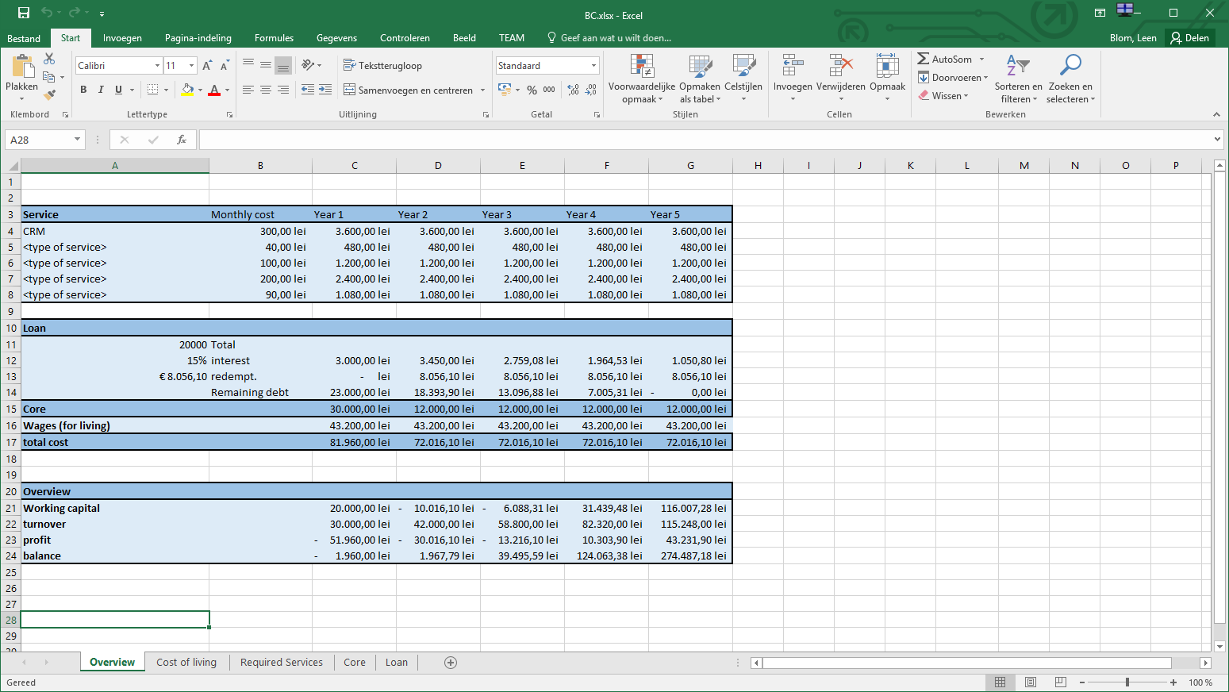

As you can see some information is already there. This is primarily to show you how things work, you should change and add information that reflects your own business.

You will find 5 tabs:

* Overview
* Cost of living
* Required Services
* Core
* Loan

Required services

There is place for 5 services that helps your business, what we call secondary processes. For instance most business need a financial service enabling customers to do online payments.

So think about the services you need and fill in the type at <type of service>. We already filled in CRM (customer relationship management) but you may change that if you don’t need a service like that.

Than try to find products and services that can fill in your need and identify monthly cost. If you found more than 1 service you may choose the best fit by setting a ‘1’ in column i. Note: all monthly cost will be added for services with ‘1’.

The Variable fields are just there for your convenience.

You will see in Overview the monthly cost of your services and cumulative year cost.

Cost of living

It is hard for us to know how much you need to live. Add all kind of costs and C29 will be used in the Overview in Wages (for living).

It is up to you how much you would like to invest in your business compared to your own wages. If you do well, you could raise your wages of course…

Core

This tab is used for the investment cost of your core service. Try to add all relevant activities: design, development and deployment on cloud infrastructure etc.

Operational cost will be used as ongoing cost to run your core service. To keep things simple it is calculated as a ratio of your investment. You will find in Overview the total cost in Year 1 and operational cost in next years.

Loan

This tab can be used to arrange your loan. Maximum is 50000 RON, but lower is often better!

And payback in less than 3 years will be rewarded by lower interes rate.

You will find the results of your loan in Overview in the box Loan.

Overview

In the overview all information is aggregated to the main financial aspects of the business case.

See the box Overview if your business is profitable.

First years may be tough, you might run into liquidity problems if balance shows negative. So be prepared to gather money from friends or ‘the crowd’. In most cases saving before you start will help because all the money you don’t need to borrow from banks or others save you from interest costs and paying back money reducing your liquidity.

1. With reservation; To be decided by prof. Alboaie